1. How would you define a function that takes two numbers as parameters and returns their sum?

function sumOfTwoNumbers(a, b) {

    return (a + b);

}

var sumResult = sumOfTwoNumbers(6, 11) ;

console.log(sumResult);

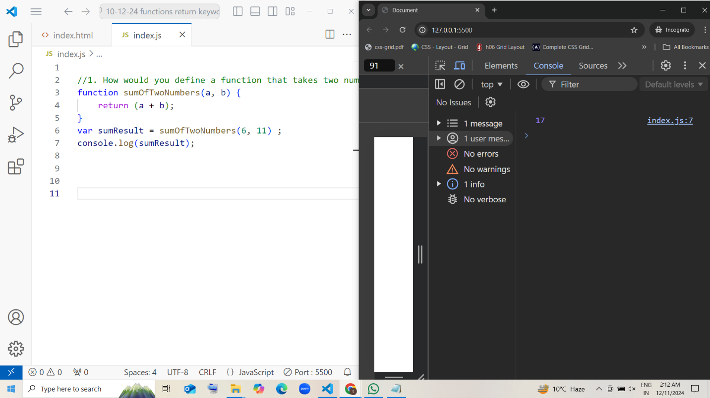

2. If you define a function that accepts a string as a parameter, how would you modify it to print the string in uppercase?

function stringUpperCase(str) {

    console.log(str.toUpperCase())

}

stringUpperCase("javascript")

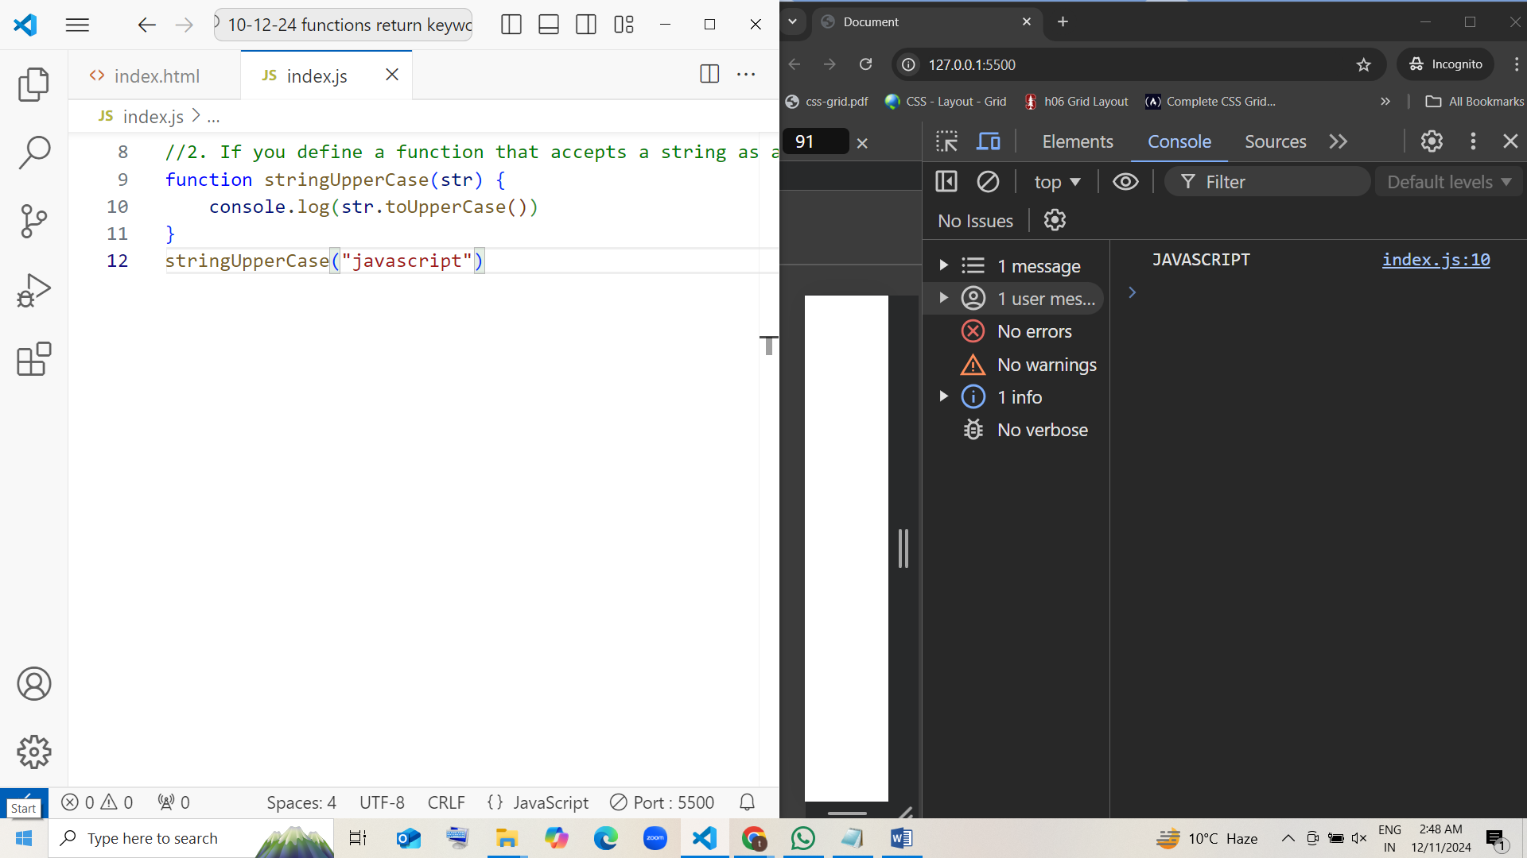

3. In JavaScript, what happens if you pass an undefined value as an argument to a function that expects a parameter?

function undefinedArugument(javascript) {

    console.log(javascript)

}

undefinedArugument()

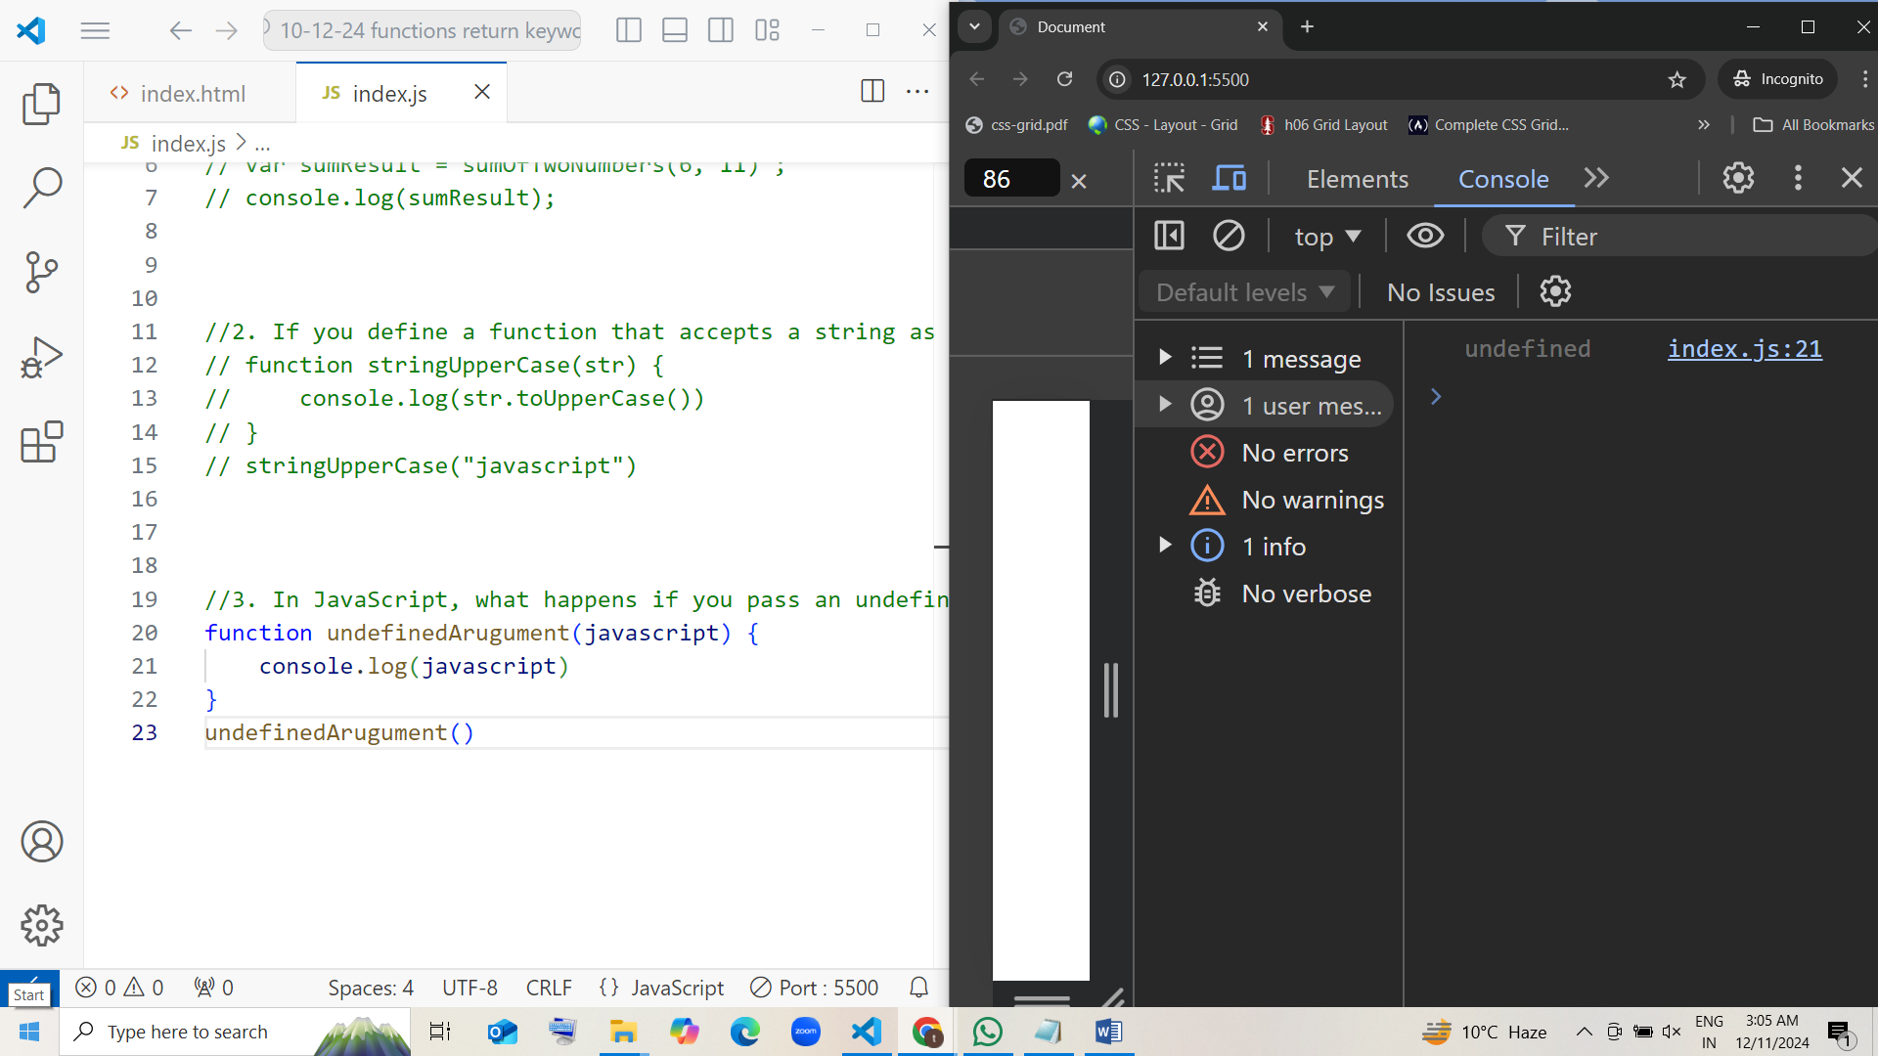

4. Suppose you have a function that takes an array as a parameter. How would you check inside the function if the array is empty?

function arrayParameter(arr) {

    console.log(arr)

}

arrayParameter([])

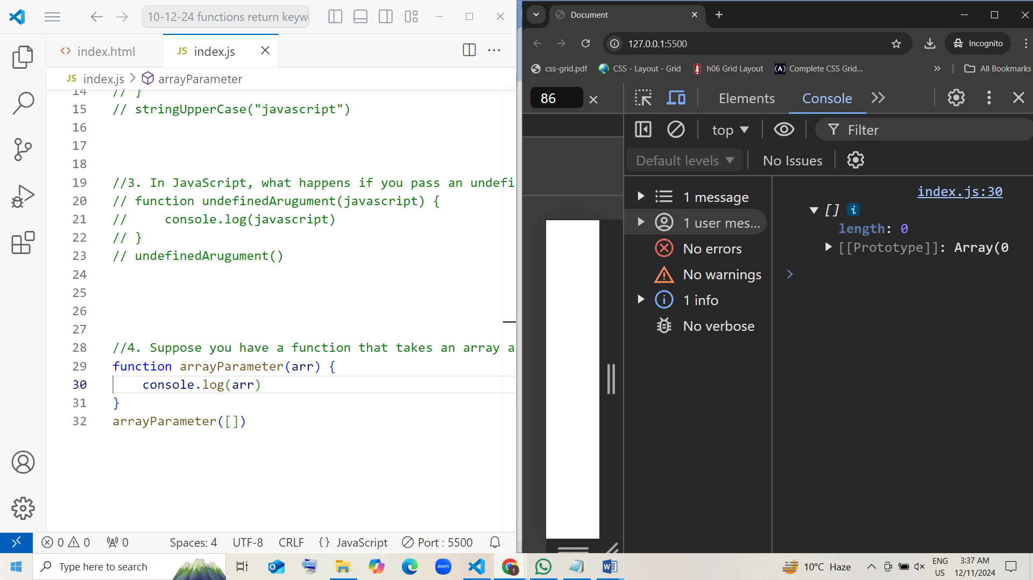

Or

function arrayParameter(arr) {

    if (arr.length === 0) {

        console.log("The array is empty.");

    } else {

        console.log("The array is not empty.");

    }

}

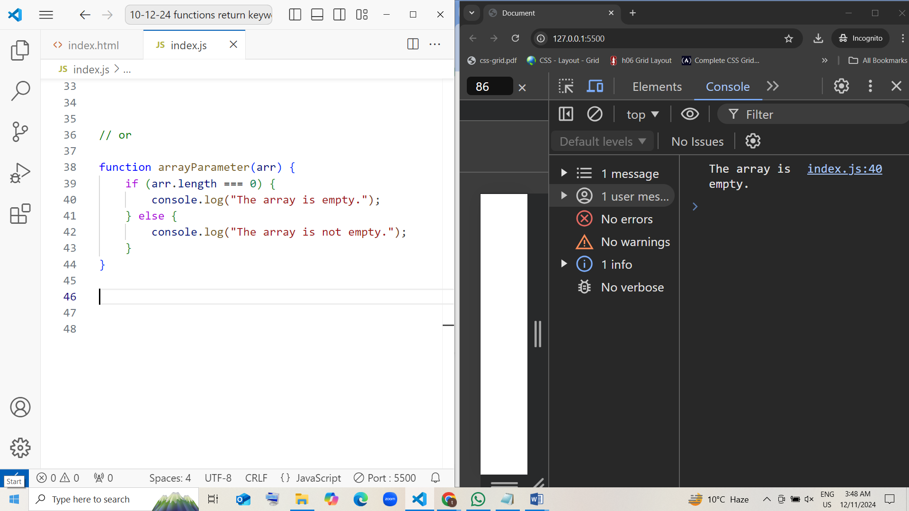

5. write a function that takes two numbers as parameters and returns their difference.

function  differenceTwoNum(a,b) {

   return (a-b)

}

var diffResult=differenceTwoNum(40,50)

console.log("The difference between two numbers:"+diffResult)

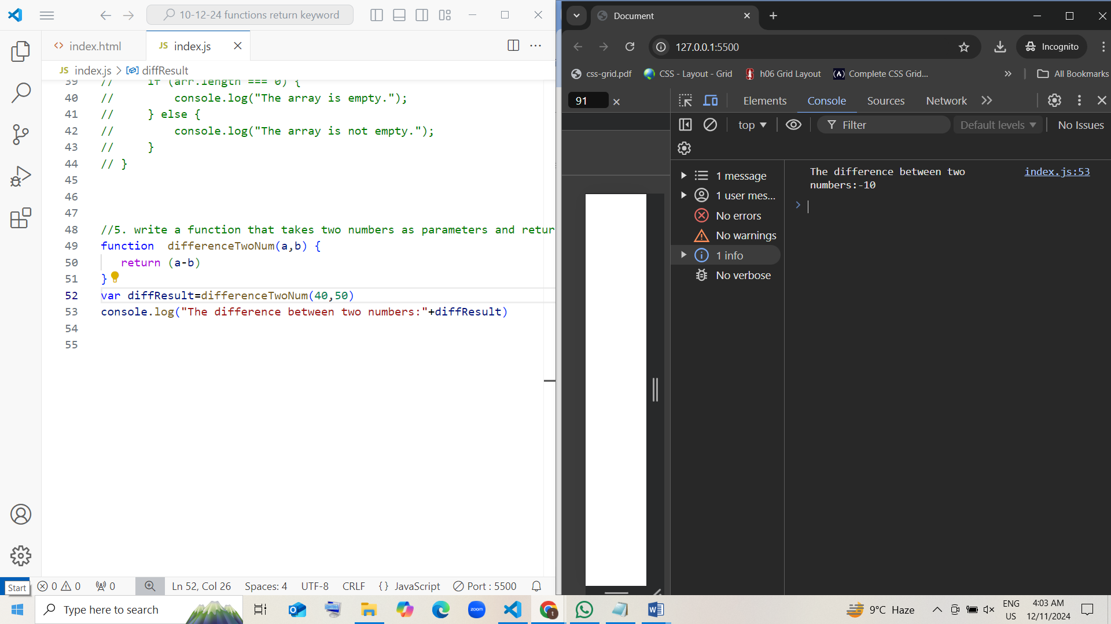

6. Define a function that accepts a name and age as parameters, and returns a string with a greeting like "Hello, [name]! You are [age] years old."

function someSentence(name,age) {

    return `Hello, ${name}! You are ${age}Years old`

}

var nameAge=someSentence("Tejaswini",23)

console.log(nameAge)

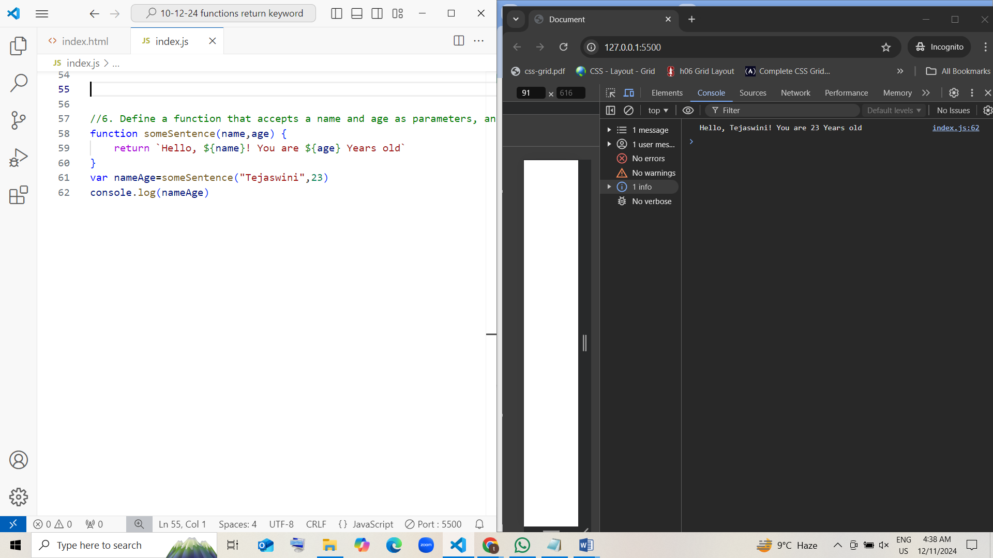

7. Write a function that takes a number as a parameter and returns true if the number is a even number, otherwise false.

function evenOrNot(a) {

    return(a%2===0)

}

var checkNum=evenOrNot(7)

console.log(checkNum)

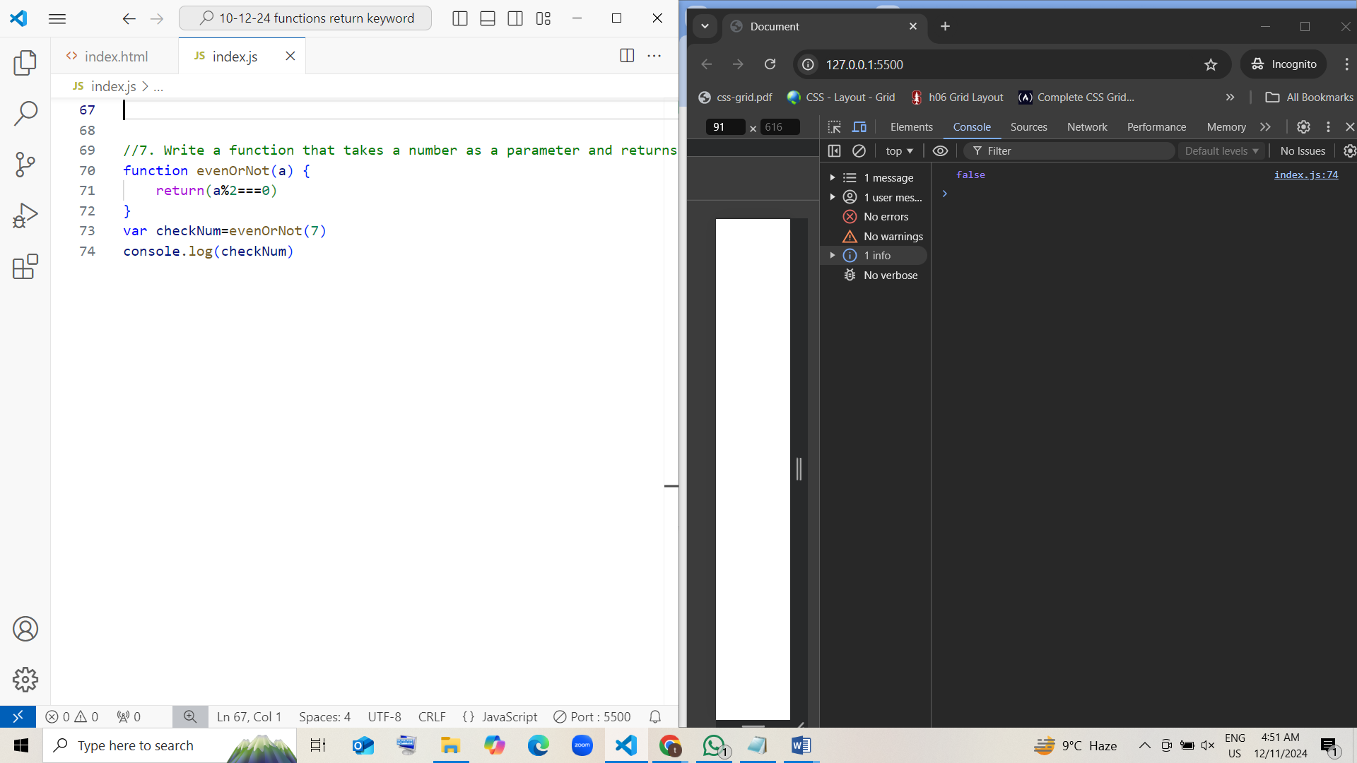

[or]

function evenOrNot(a) {

if (a % 2 === 0) {

return true; // [even]

} else {

return false; //[odd]

}

}

var checkNum = evenOrNot(7);

console.log(checkNum);

